We have set our local priorities for the next few months as:
Safer Neighbourhood Team for Bishopstoke, Fair Oak & Horton Heath

- Reducing anti social behaviour. We will do this by working closely with other agencies such as local schools and youth groups to educate young people as well as identifying hotspots where ASB is happening and planning structured patrols, particularly over weekends and evenings where incidents are higher. Areas currently highlighted as Latham Road, Centurion Park, Lapstone Pavilion and Blackberry Drive.

- Reducing criminal damage and vandalism associated with anti social behaviour. We will do this by working with other agencies and initiating projects with young people in the community, First Wessex Housing, the Community Safety Partnership at Eastleigh Borough Council. We are planning a community event in the Bishopstoke area around Stoke Park Woods in the Spring. Further information on this can be found on the Hampshire Constabulary website.

- Reducing road traffic accidents, speeding and resolving parking issues around schools. We will do this by working with HCC and other agencies around education and speed enforcement at priority locations. We will also be supporting the existing Fair Oak Community Speedwatch scheme and the new Bishopstoke scheme.

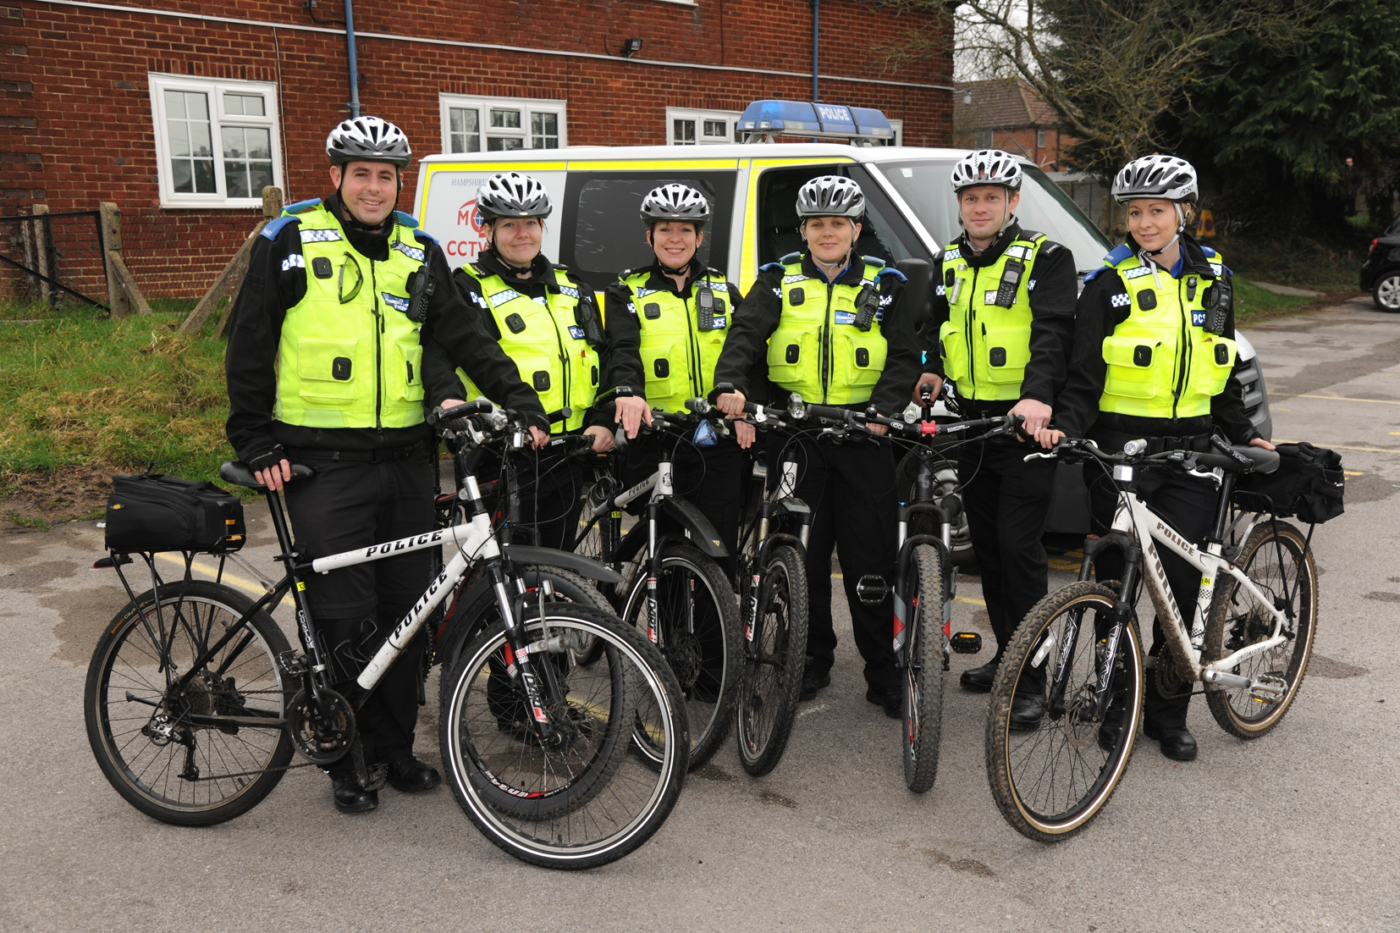

Please follow us on Twitter @EastleighPolice or have a look at our website www.hampshire.police.uk

